|  |  |
| --- | --- |
|  | *Abstract*  **Visualisation GDP,Life Expectancy and Smartphone users for 20 top countries in ranking**  Shahin February 2023 |

**Contents**

Task1 ………………………………………………………………………………………………………….2

Task2 ………………………………………………………………………………………………………….3

Task3 ………………………………………………………………………………………………………….7

**Policies and Procedures**  
  
As a data analyst, it is essential to adhere to certain policies when working with data to ensure the accuracy, integrity, and confidentiality of the data. Here are some policies that should be followed when working with data:

Data Protection and Security Policy: It is crucial to ensure that data is protected from unauthorized access, modification, and disclosure. This policy ensures that sensitive data is only accessible to authorized personnel, and data breaches are prevented.

Data Privacy Policy: This policy ensures that personal data is protected, and the rights of data subjects are respected. It also outlines the procedures for collecting, processing, and sharing personal data.

Data Retention Policy: This policy outlines how long data should be kept, when it should be deleted, and how it should be disposed of. This ensures that data is not retained for longer than necessary and prevents data from being lost or stolen.

Data Quality Policy: This policy ensures that data is accurate, complete, and consistent. It outlines the procedures for data validation, verification, and correction.

Data Governance Policy: This policy ensures that data is managed effectively, and the responsibilities for data management are clearly defined. It outlines the procedures for data sharing, access, and usage.

It is important to be aware of these policies as a data analyst because data is a valuable asset, and any mishandling of data can lead to significant consequences, such as loss of reputation, legal penalties, or financial loss. Adhering to these policies ensures that data is used ethically, legally, and in a way that benefits the organization and its stakeholders.

1. Set a password to protect the workbook

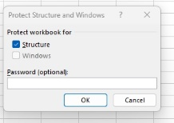

2. Highlight column C and change the data to display in British Pound symbol

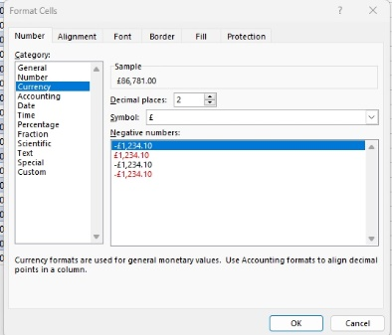

3. Turn the GDP sheet into a table.

4. Filter the table to display only the information for 2019

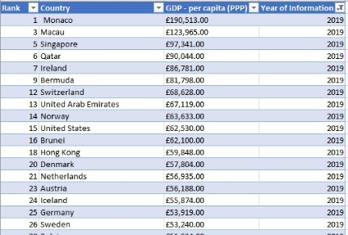

5. Next create a chart that will only display the following data ‘Rank, Country and GDP - per capita (PPP). The chart can be anything as long as it is suitable.

* 1. 6. Using your creative skills edit the chart a. Add a title
  2. b. Add X and Y axis labels
  3. c. Make the chart visually pleasing
  4. 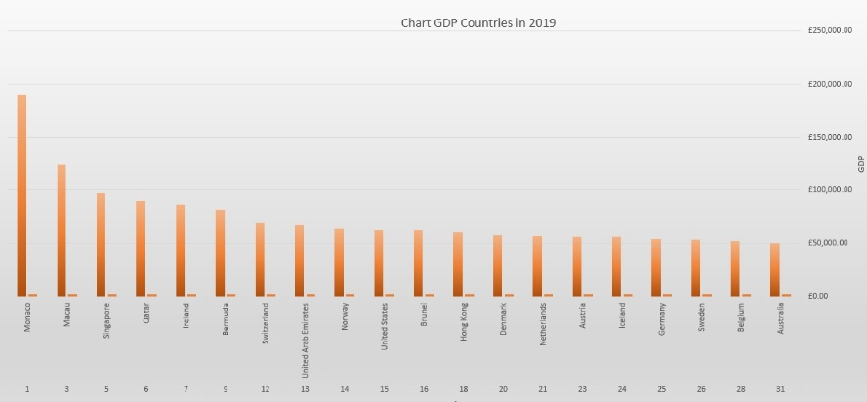
  5. 7. Move the chart to a new sheet tab and label with a suitable name
  6. 8. Create a sort for the top 20 highest ranking counties
  7. 9. Next create a new Bar chart to display the 20 highest ranking countries

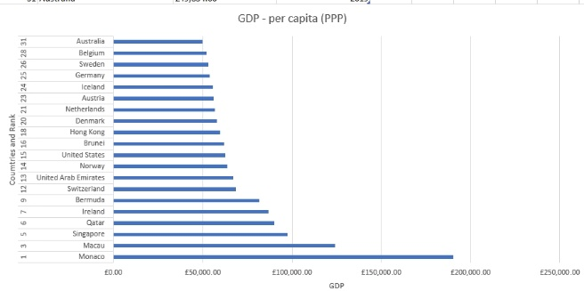

10. Colour the background by highlighting the area underneath the table as shown below. Find the add a fill colour icon and select a colour.

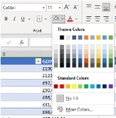

11. The next task is to create 3 macro buttons, print the sheet, Save the file and Copy the sheet.

12. Using the copy macro, copy the sheet and then paste it into a new word document keeping the formatting. Give the page a title ‘GDP (Gross domestic product)’ .

13. Save your document as ‘Word Gross domestic product report 1’

14. Before we finish with our excel table ‘Gross domestic product’ sheet, we will add a header and footer to our table. Select the ‘View’ tab from the top and find the ‘workbook views’ area, as seen below:

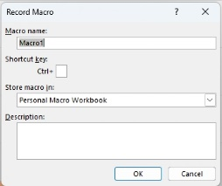

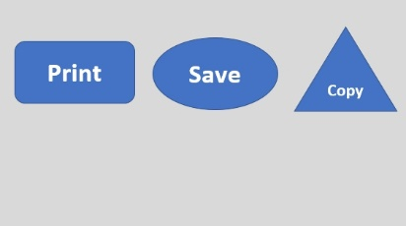

1) Import data

2) Set relationships:

You have three sheets and the common column for all of them is country, so the visual arrangement of the sheets does not matter Only the columns that you use to create the relationship matters. You can arrange the sheets in a straight line as seen below:

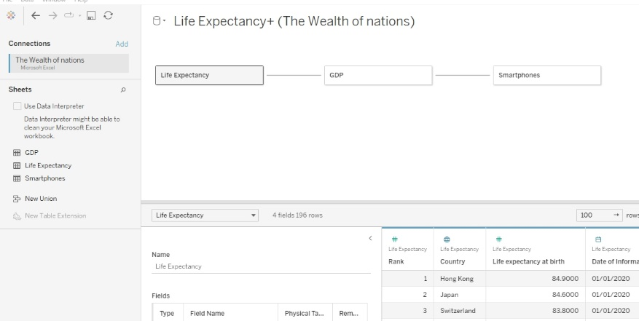

3) Check data types.

4) Build charts

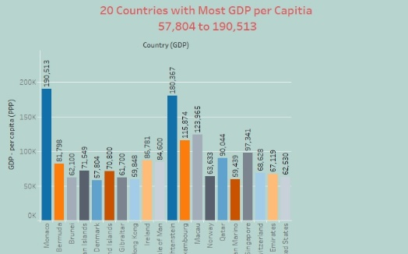

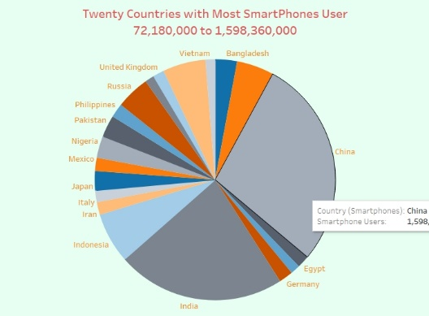

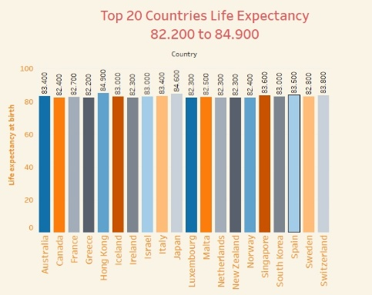

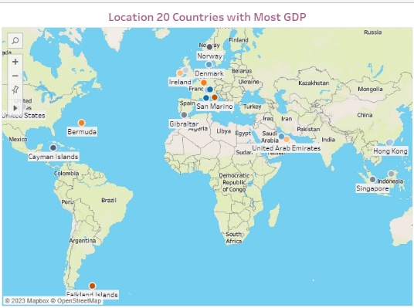

5) As you create your charts, if you see a little gray box containing a count of null values, select the filter option.

6) Build your dashboard

